An Internship Report
Of
Fundraising Internship
Submitted
To
School of Computer Science and Engineering
IILM University, Greater Noida, U.P.

In partial fulfilment of the requirement of degree of
B-Tech (CSE)
By
Roll Number of Student:- 25SCS1003001059
Name of Student: KESHAV KUMAR
Batch: 2026-27

CANDIDATE'S DECLARATION
I, KESHAV KUMAR, do hereby declare that the internship report titled “Fundraising Internship” has been completed by me to fulfil the requirement for the award of the degree of Bachelor of Technology in Computer Science and Engineering. All the references have been quoted and I have not taken as such any material from any other source. I affirm that this report is my own and has not been submitted to any other institute for any degree/diploma requirement, and further I shall be solely responsible for any kind of copyright violation in this regard.
Student Name: KESHAV KUMAR
Roll No.: 25SCS1003001059

ACKNOWLEDGEMENT
I am using this opportunity to express my gratitude to everyone who supported me throughout the Internship Program. I am thankful for their aspiring guidance, invaluably constructive criticism and friendly advice during this work. I am sincerely grateful to them for sharing their truthful and illuminating views on a number of issues related to this work.
I would like to thank Mr. Akash Kumar, Managing Director, and the entire team at Pawzzitive Welfare Foundation for providing me the opportunity and the structured platform to learn and gain hands-on exposure in the domain of fundraising for animal welfare. I am also thankful to my institute, IILM University, Greater Noida, and the faculty of the School of Computer Science and Engineering for their continuous support and encouragement.
I express my gratitude to my parents for their blessings.
Student Name: KESHAV KUMAR
Roll No.: 25SCS1003001059

TABLE OF CONTENTS
1. Candidate's Declaration
2. Acknowledgement
3. Internship Completion Certificate -
4. Project Description
4.1 Introduction
4.2 Organization Profile
4.3 Problem Statement
4.4 Project Objectives
4.5 Scope of the Project
4.6 Technologies and Tools Used
4.7 System Architecture
4.8 Methodology
4.9 Expected Outcomes
4.10 Certificates of Completion and Communication Proof
5. Bibliography/References

3. INTERNSHIP COMPLETION CERTIFICATE

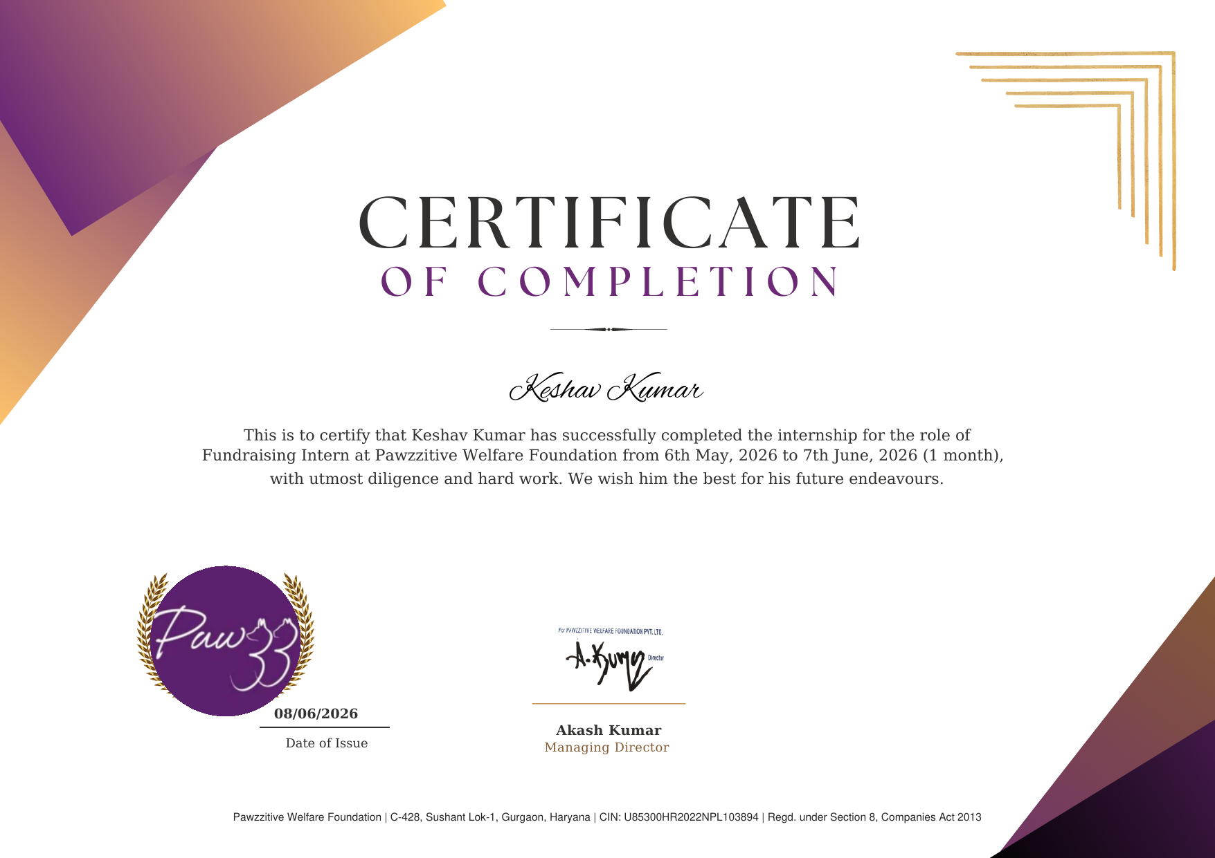

4. PROJECT DESCRIPTION

4.1 Introduction
This report presents a detailed account of the 1-month Internship undertaken in the domain of Fundraising at Pawzzitive Welfare Foundation. The internship was carried out from 6th May, 2026 to 7th June, 2026 as part of the requirement of the Bachelor of Technology (Computer Science and Engineering) programme at IILM University, Greater Noida. The primary aim of this internship was to bridge the gap between technical understanding and real-world application of digital outreach, campaign planning, and resource mobilization for a social cause.
The internship followed a structured curriculum that combined conceptual learning with hands-on assignments in donor communication and social media strategy. On successful completion of all the requirements, an Internship Completion Certificate was awarded by Pawzzitive Welfare Foundation.

4.2 Organization Profile
Pawzzitive Welfare Foundation is a registered non-profit organization under Section 8 of the Companies Act 2013 (CIN: U85300HR2022NPL103894), operating out of Gurgaon, Haryana. The foundation is dedicated to animal welfare, focusing extensively on the rescue, rehabilitation, and medical treatment of stray animals. Led by Managing Director Mr. Akash Kumar, the organization partners with volunteers and utilizes digital fundraising drives to sustain its impactful programs.

4.3 Problem Statement
Animal welfare non-profits such as Pawzzitive Welfare Foundation depend heavily on continuous donor engagement to fund rescue operations and medical treatments. However, limited visibility, low awareness among potential donors, and inconsistent outreach on digital platforms often restrict the funds an organization can mobilize. The problem addressed by this internship was to understand and practically implement a complete lifecycle of digital fundraising – from identifying the cause, reaching out to potential donors via social media, and ultimately converting that engagement into actual contributions for the foundation.

4.4 Project Objectives
- To understand the working and outreach model of an animal welfare non-profit organization.
- To plan and execute online/social media fundraising campaigns for Pawzzitive Welfare Foundation.
- To identify and engage potential donors through digital communication channels.
- To communicate the Foundation's mission, causes, and impact effectively to prospective donors.

4.5 Scope of the Project
The scope of this internship spans the entire digital fundraising pipeline – starting from cause identification, content planning, launching campaigns across social media channels, and following up with interested individuals. It also covers the management of donor relationships over a short timeframe. The internship was limited to online fundraising activities and did not involve on-ground physical events.

4.6 Technologies and Tools Used
- Digital Communication Platforms: WhatsApp, Email
- Social Media Platforms: Instagram, Facebook, LinkedIn
- Content Creation Tools: Canva (for designing posters and outreach graphics)
- Data Management: MS Excel / Google Sheets for tracking donor engagement

4.7 System Architecture
The general workflow followed during the internship for deploying a fundraising solution can be summarized in the following layers:
1. Cause Identification: Selecting specific animal rescue cases requiring funds.
2. Content Planning: Drafting appealing messages and digital posters.
3. Outreach Layer: Utilizing digital channels and social media to broadcast the message.
4. Engagement Layer: Communicating directly with prospects, answering queries, and providing foundation details.
5. Conversion & Reporting: Securing donations and tracking the collected funds in structured sheets.

4.8 Methodology
The internship followed a structured methodology, summarized below:
- Orientation: Understanding Pawzzitive Welfare Foundation's mission and target donor base.
- Campaign Planning: Identifying fundraising causes and planning content/messaging for outreach.
- Outreach Execution: Sharing campaign content across social media and personal networks.
- Donor Engagement: Responding to donor queries and encouraging contributions.
- Tracking & Follow-up: Maintaining a record of outreach activity and follow-ups.

4.9 Expected Outcomes
- Ability to independently plan and launch a digital fundraising campaign.
- Practical understanding of donor psychology and social media algorithms for better reach.
- Measurable financial contributions directed toward the foundation’s causes.
- A completed internship demonstrating enhanced communication, marketing, and project management skills.

4.10 Certificates of Completion and Communication Proof
The Internship Completion Certificate issued by Pawzzitive Welfare Foundation, confirming successful completion of the 1-month Fundraising Internship (6th May, 2026 to 7th June, 2026), is attached in Chapter 3 of this report.

5. BIBLIOGRAPHY/REFERENCES
1. Pawzzitive Welfare Foundation, “Certificate of Completion – Fundraising Intern,” Issued to Keshav Kumar on 08/06/2026.
2. IILM University, Greater Noida, Academic Guidelines for Internship Reports, 2026-27.
3. Ministry of Corporate Affairs, Government of India, Section 8 Companies Act 2013 Guidelines.
4. Pawzzitive Welfare Foundation Official Documentation and Campaign Materials.
5. URL Verification - https://www.pawzz.org/

